

Thesis Progress Management and Archiving System



|  |
| --- |

Thesis Progress Management and Archiving System

Disclaimer

Thesis Progress Monitoring and Archive Management System for WVSU CICT is the name of the system project that has been submitted to West Visayas State University's College of Information and Communications Technology in partial fulfillment of the degree's information systems requirements. With the exception of the mentioned wording, it is our own creation.

We hereby give the College of Information and Communications Technology permission to freely use, publish in a national or international journal or conference, reproduce, or distribute publicly the printed and electronic versions of this system project and its associated documentation, in whole or in part, as long as we are credited.

Azucena, Angie Rose

Gemalaya, Dion Rey

Sotela, Evelyn

Tagudando, Eden Faith

Table of Contents

**Introduction 4**

**About the Thesis Progress Monitoring and Archive Management System 5**

Features 6

Coordinator Side 6

Adviser Slide 7

Panel Slide 7

Student/Public Side 7

**System Requirements and Installation 8**

System Requirements 8

Installation/ Set-up 8

Requirements 8

Installation/Setup 8

**System Features Usage with Snapshots 9**

**Troubleshooting 17**

**FAQ 17**

**Contact Details 20**

System’s Main Functions Guide Getting Started

## 

# Introduction

This project, titled Thesis Progress Monitoring and Archive Management System, was created with PHP and the MySQL database.

This is a web-based application that serves as a repository for students' thesis or capstone projects.

The primary goal of this application is to provide students at a specific university or college with online access to store their final year projects and to allow lower year students to find references and ideas for their future or upcoming final year project.

The system was written in PHP/OOP (Object-Oriented Programming) and includes numerous features and functionalities typical of this type of system.

Using the Bootstrap Framework and the AdminLTE Template, this has user-friendly functionalities and a pleasant user interface.

## 

# About the Thesis Progress Monitoring and Archive Management System

We developed this project using the following:

* XAMPP v3.3.0 as my local web server that has a PHP Version 8.0.7
* PHP Language
* MySQL Database
* HTML
* CSS
* JavaScript
* jQuery
* Ajax
* Bootstrap
* AdminLTE
* and some other plugins/libraries.

This Thesis Progress Monitoring and Archive Management System has 5 modules which are the Coordinator Module, Thesis Instructor Module, Adviser Module, Panel Module and the Student Module:

1. The Coordinator Module is the part of the system where the school management can manage the system information and important list on the system. The Admin Users has full access to all features and functionalities of the system Admin Panel and that includes the list of Staff users. The Staff Users only have limited access to the said system side. They can only manage the submitted projects of the students and manage the registered student list.
2. The Thesis Instructor Module is the part of the system that allows the thesis instructor to assign groups of students and a leader to every group.
3. The Adviser Module allows advisers to accept or reject thesis advisers' invitations from students. It also allows them to monitor the progress of the students' manuscript.
4. The Panel Module is the component of the system that enables the panel to evaluate students' presentations during thesis defenses and to accept or deny a thesis.
5. The Student Module allows students to manage their group, send thesis adviser invitations, upload their manuscript for progress monitoring, contact their thesis instructor for queries, view the schedules of their defense, and see which panels have already rated their manuscript and whether their thesis was accepted or rejected.

## Features

### Coordinator Side

* Secure Login and Logout
* Dashboard
* Manage Department List (CRUD)
* Manage Course/Curriculum List (CRUD)
* Manage Archives
  + List All Projects Submitted by the students
  + View the project details
  + Publish the project to the Public
  + Review To Published documents
* Manage Admin
  + Assigned New Administrator (Adviser, Instructor, Panel )
  + Delete Admin and Edit
  + Edit the student handle of the Instructor
* Manage Student Accounts
  + Assigned Panel for the students
  + Update Panel for the students
* Manage Users list (CRUD)
* Manage Account Details/Credentials
* Manage System Information

### Adviser Slide

* Secure Login and Logout
* Dashboard
* Messages
* Schedule Task
* Check Pending Documents of the student
* Invite
  + Can Accept or Decline Invitations

### Panel Slide

* Secure Login and Logout
* Dashboard
* Can Edit Task Category

### Student/Public Side

* Secure Login and Registration
* Home Page *(displays the website's welcome message)*
* Submit Thesis/Capstone Project
* Project List
  + List All Published Projects
  + List All Published Projects Per Department
  + List All Published Projects Per Curriculum
  + The list has a pagination feature
  + Published Project View Page
  + Edit Project Details *(if the logged-in user is the one who submits)*
  + Delete Project *(if the logged-in user is the one who submits)*
* Profile
  + Display the Student System Information
  + Update Student Details/Credentials
  + List/Manage Submitted Projects
* Search Project
* Update Account Information/Credentials
* Logout

# System Requirements and Installation

## System Requirements

7.4 or later on Windows, v1. 8.1 or later on Linux, and v1. 8.2 or later on Mac OS X. Bitnami for XAMPP works properly on top of the portable version.

XAMPP requires only one zip, tar, 7z, or exe file to be downloaded and run, and little or no configuration of the various components that make up the web server is required. The Windows version of XAMPP requires Microsoft Visual C++ 2017 Redistributable.

## Installation/ Set-up

### Requirements

* Download and Install any local web server such as XAMPP/WAMP.
* Download the provided source code zip file. (*https://github.com/dreygmly13/west*)

### Installation/Setup

1. Open your XAMPP/WAMP's Control Panel and start Apache and MySQL.
2. Extract the downloaded source code zip file.
3. If you are using XAMPP, copy the extracted source code folder and paste it into the XAMPP's "htdocs" directory. And If you are using WAMP, paste it into the "www" directory.
4. Browse the PHPMyAdmin in a browser. i.e. http://localhost/phpmyadmin
5. Create a new database naming west.
6. Import the provided SQL file. The file is known as west.sql located inside the database folder.
7. Browse the Online Thesis Archiving System in a browser. i.e. http://localhost/west/

# System Features Usage with Snapshots

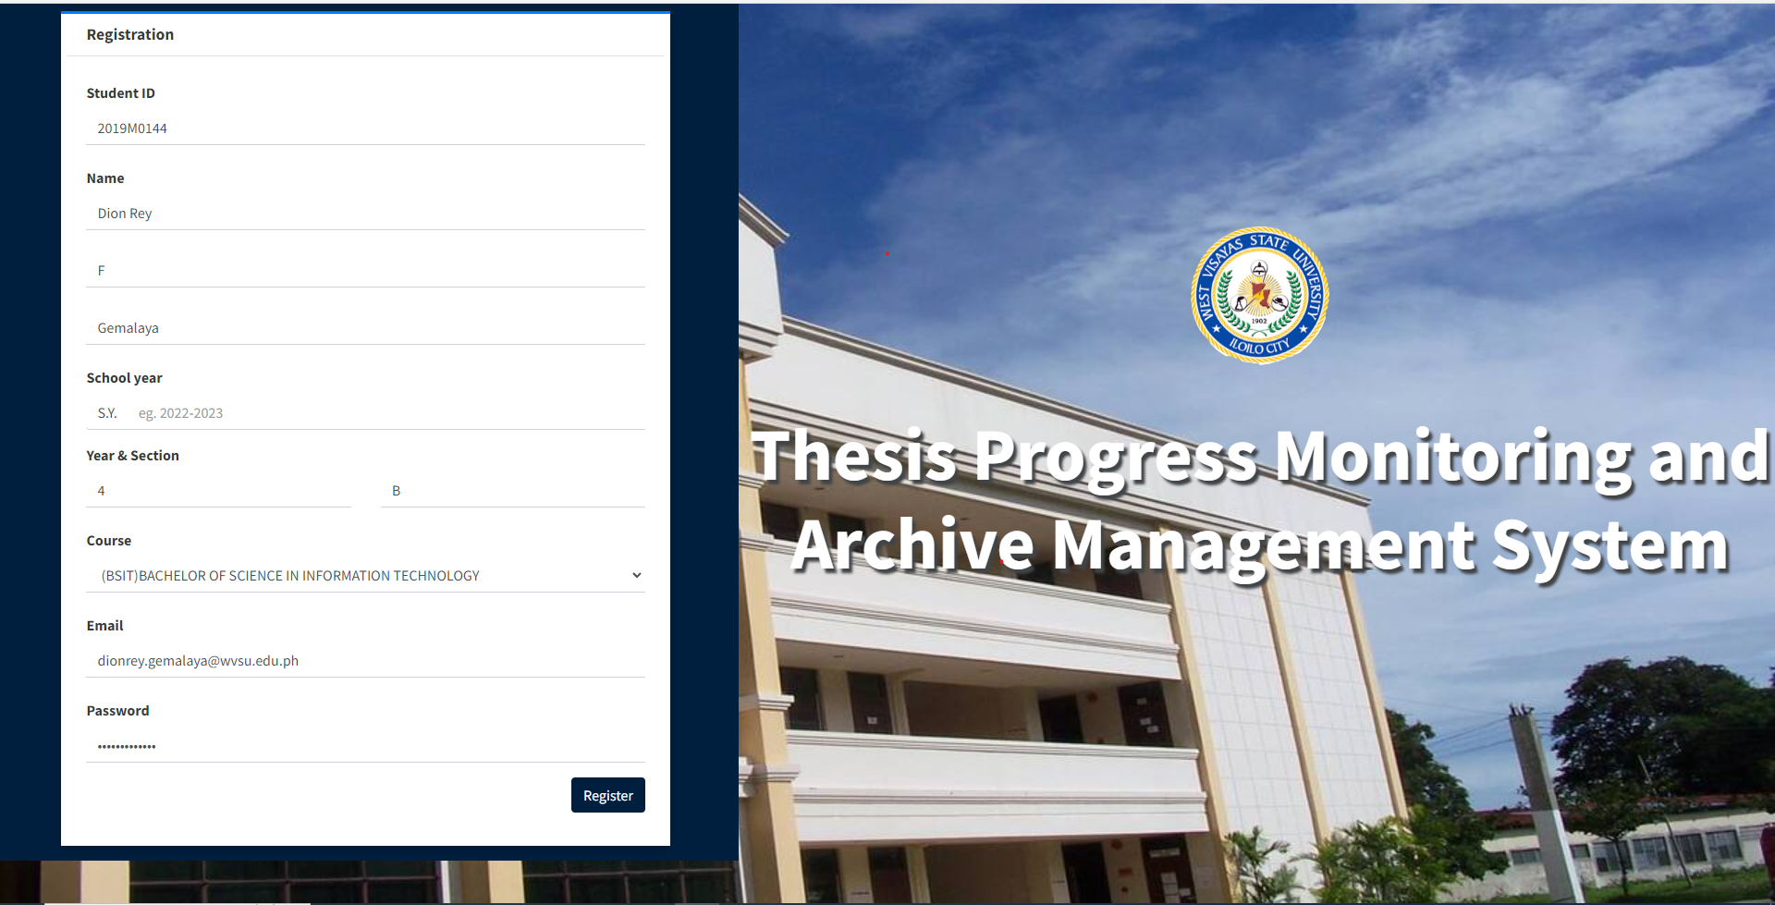

The registration screen interface for students allows for the creation of a user account by inputting various personal details, including the student's identification number, full name, academic level, preferred password, email address, as well as the course, year, and section of enrollment.

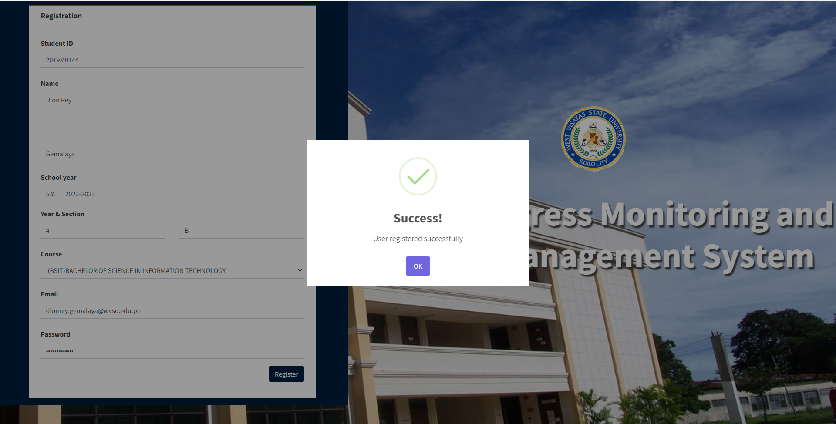

After registration, the admin will confirm the students registration.

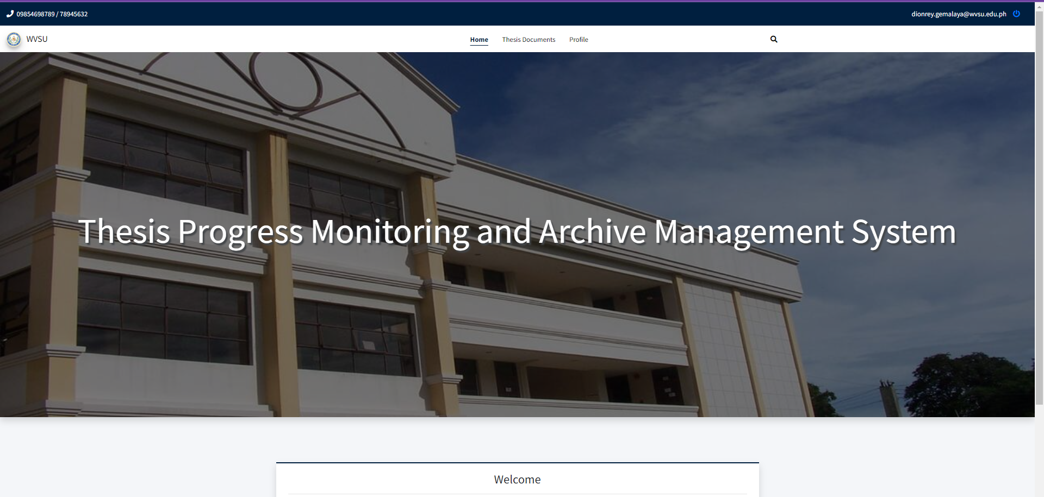

Home screen interface of students, where they see the navigation button for thesis documents and profiles.

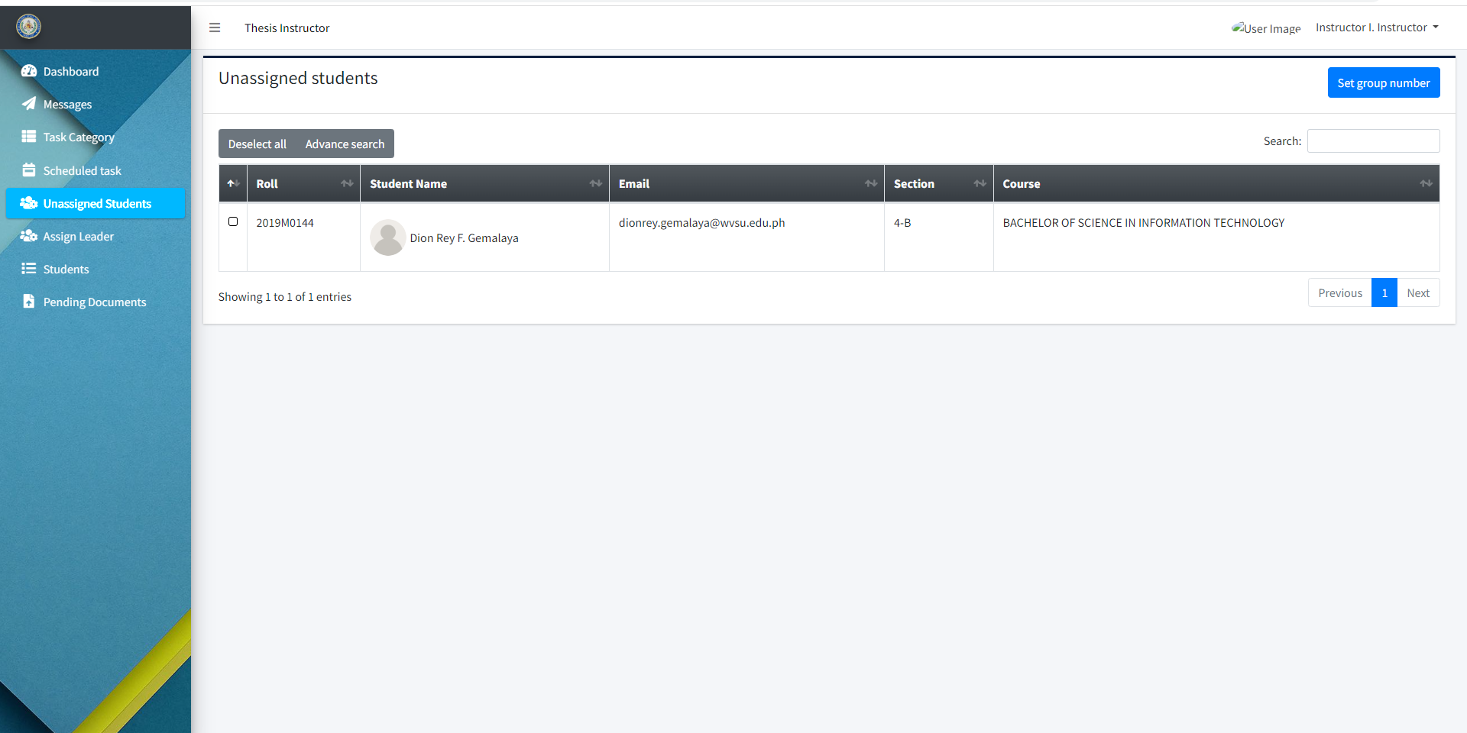

Instructor dashboard for verifying student registration.

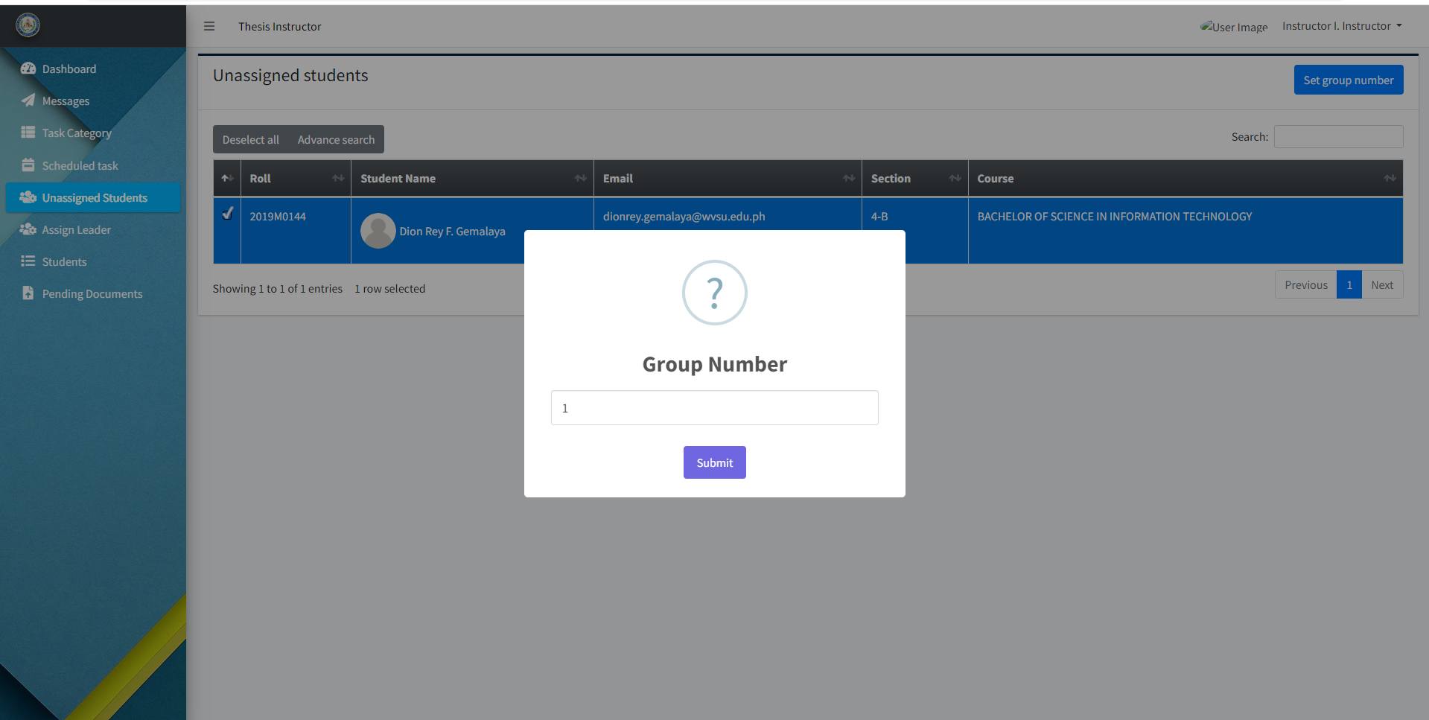

The "unassigned students" option allows the thesis instructor to create and assign the group number of the students.

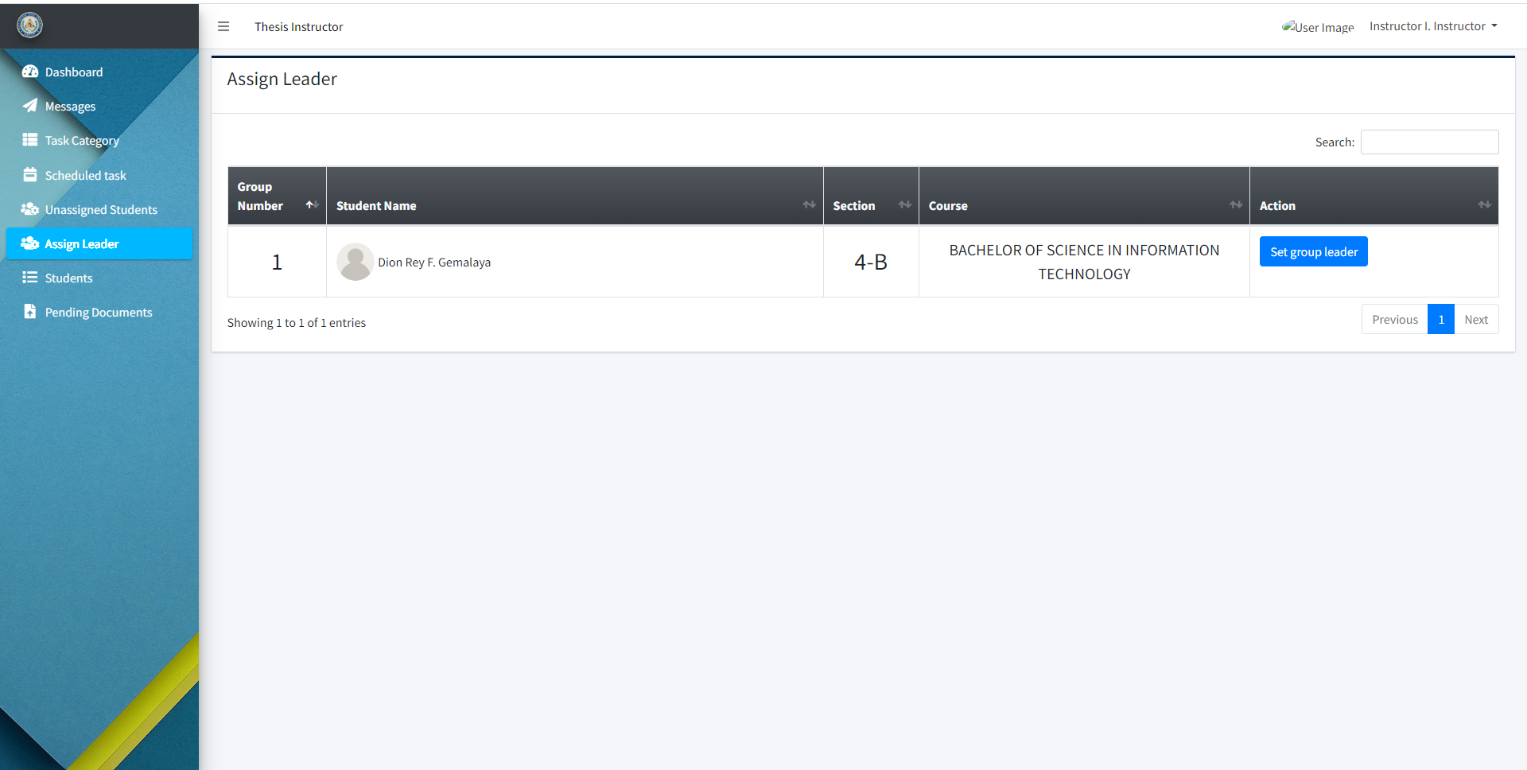

The "Assign Leader" option allows the thesis instructor to assign the leader of the group.

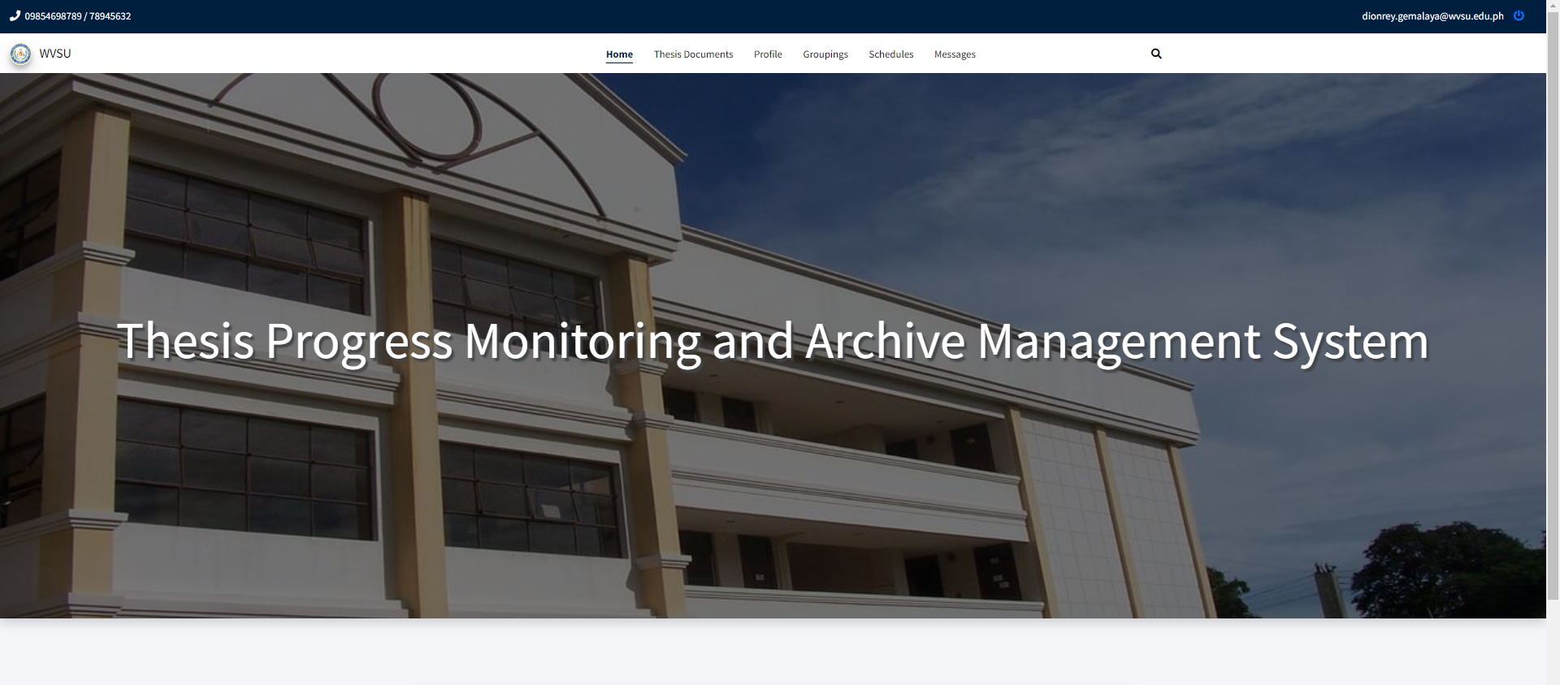

Updated Student Dashboard after the confirmation of their registration.

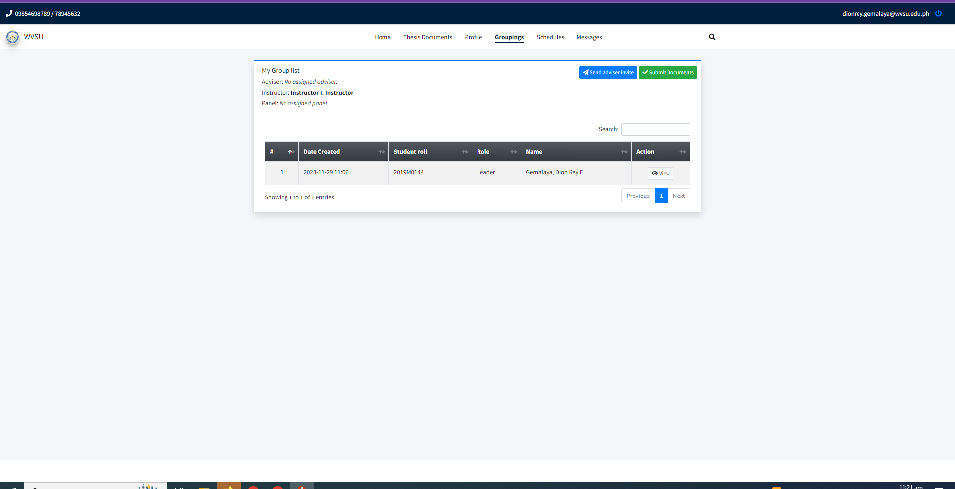

The "Groupings" tab serves as an interface for students to send invitations to their advisers and submit documents.

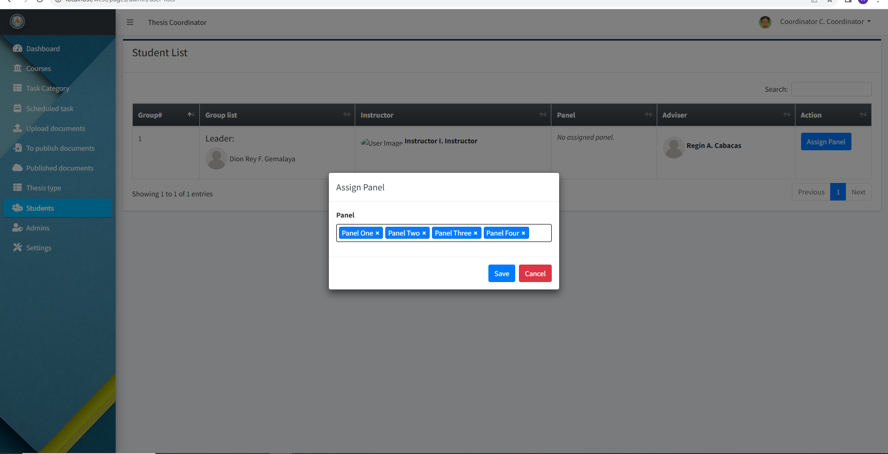

“Students” dashboard allows the thesis coordinator to assign panels for each group.

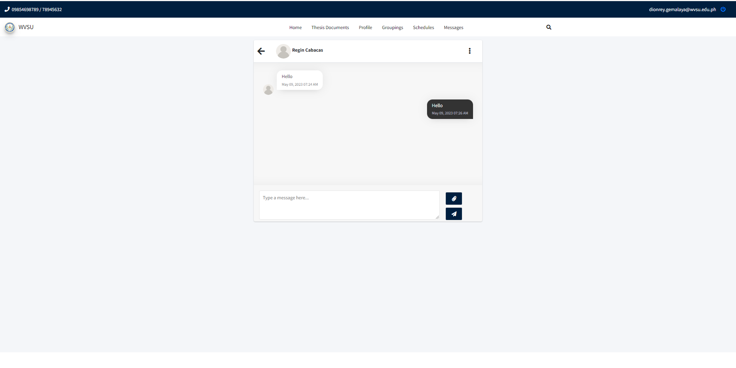

Messaging feature that enables students and their thesis adviser to communicate with each other through texts.

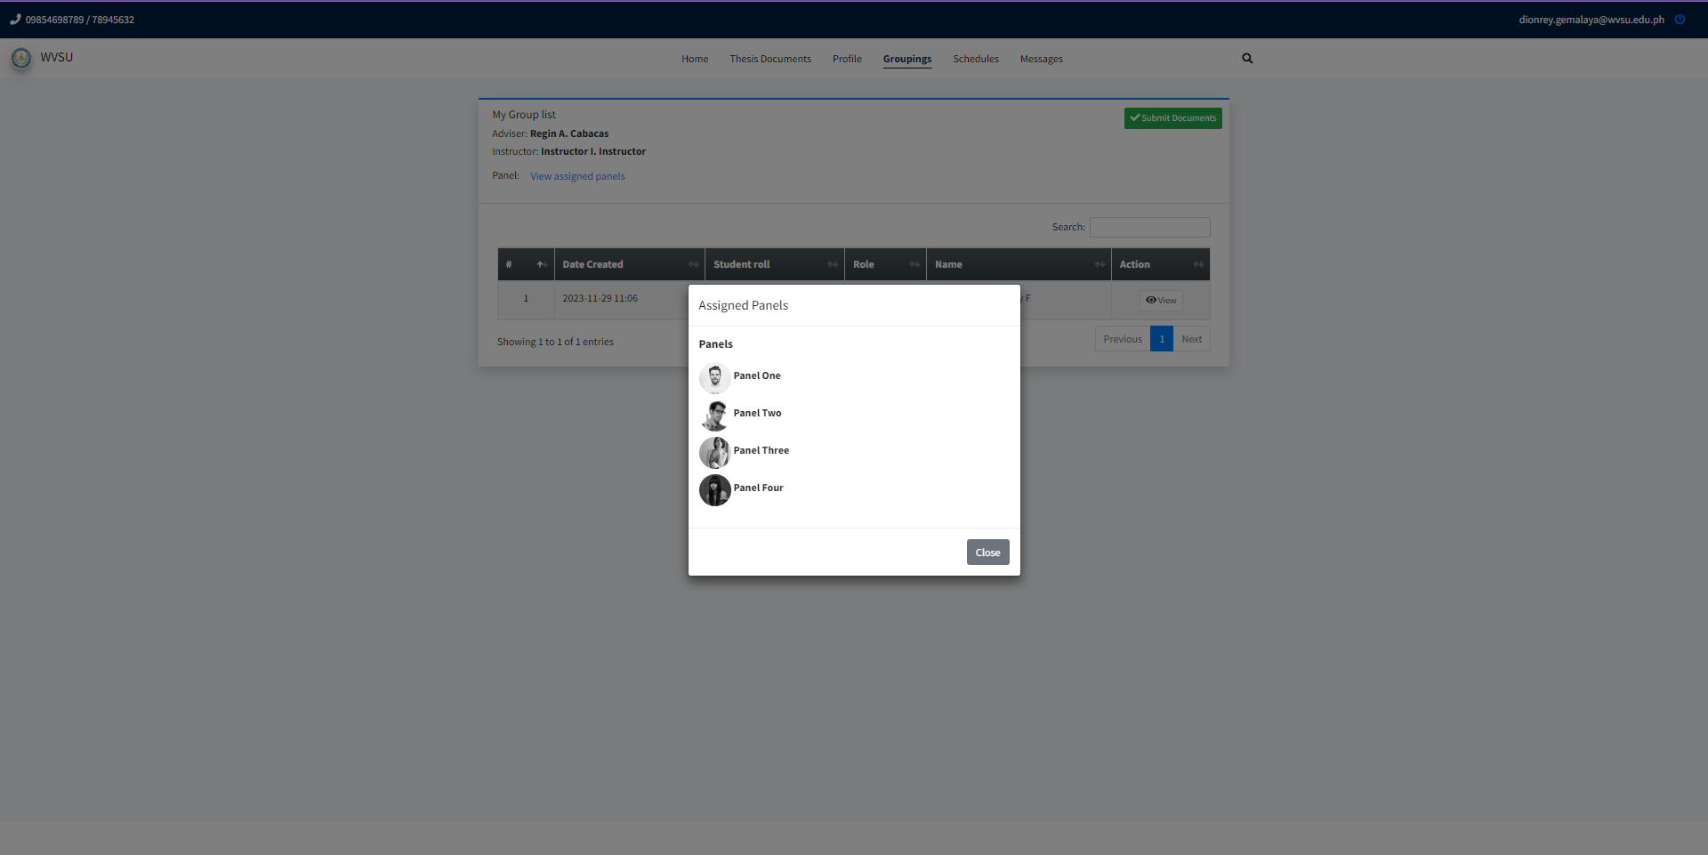

“Groupings” tab from the student dashboard that provides a preview of the assigned panel for their thesis defense.

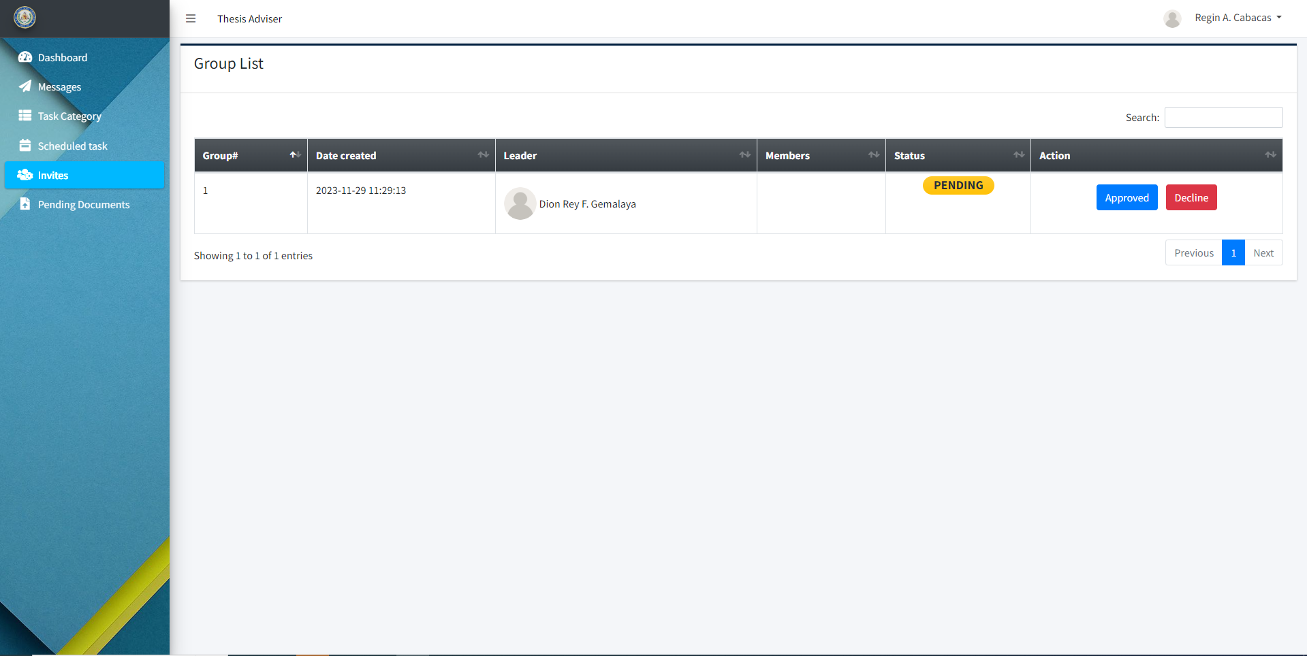

The “Invite” tab in the Thesis Adviser dashboard allows the thesis adviser to accept or reject the thesis adviser invitation sent to them by the students.

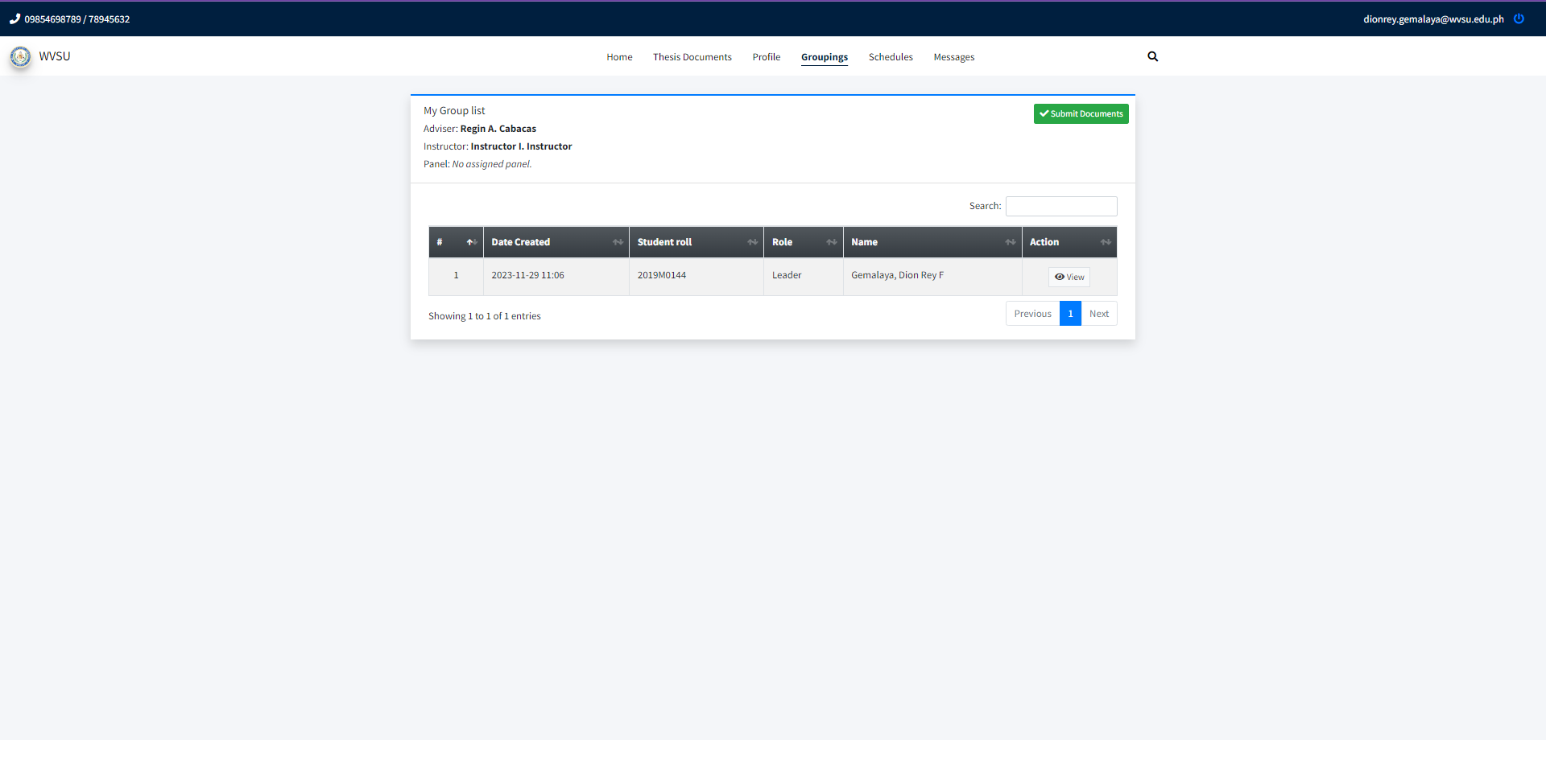

After being accepted by the thesis adviser, the student can start submitting their thesis documents.

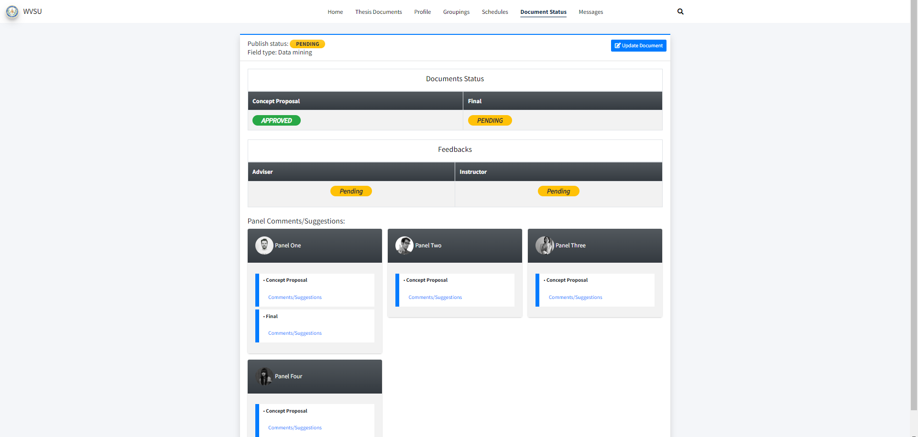

Students can track the status of their uploaded documents whether it’s approved or disapproved and view the panel's comments/ suggestions.

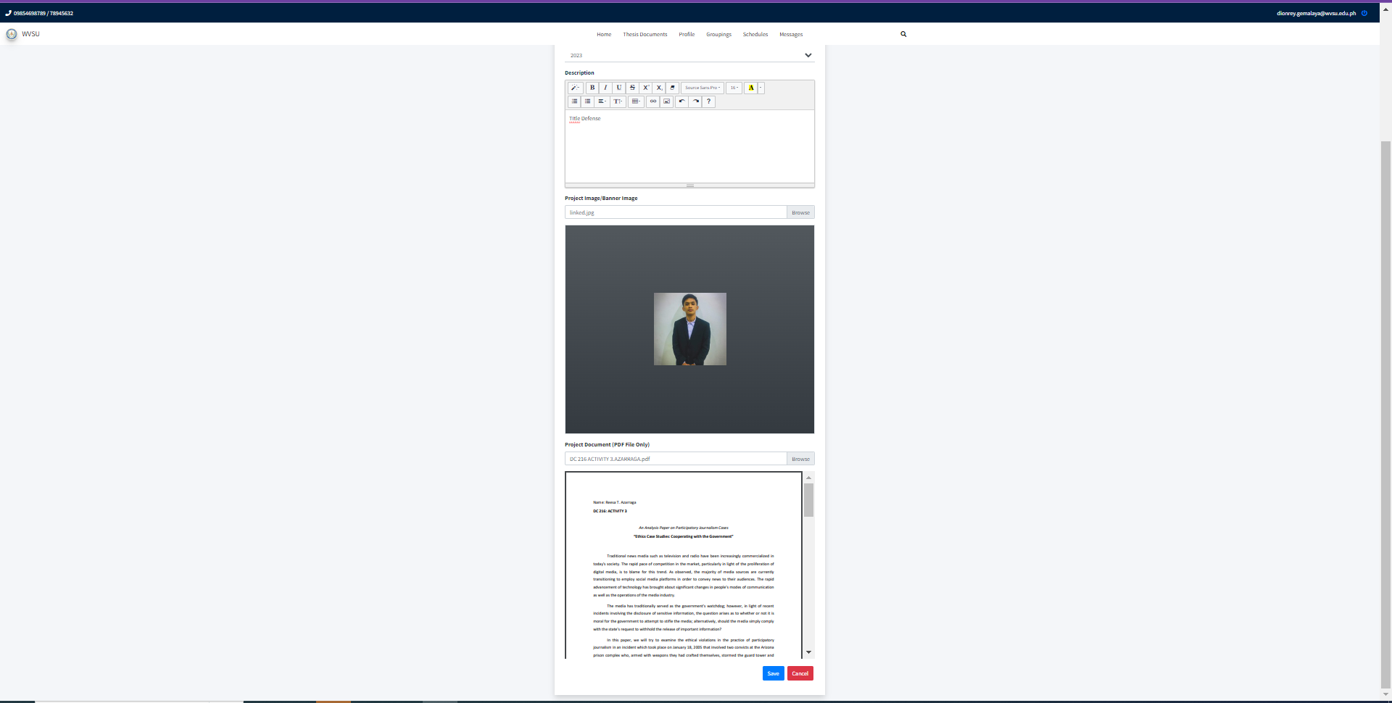

Preview page for the uploading of documents for the defense.

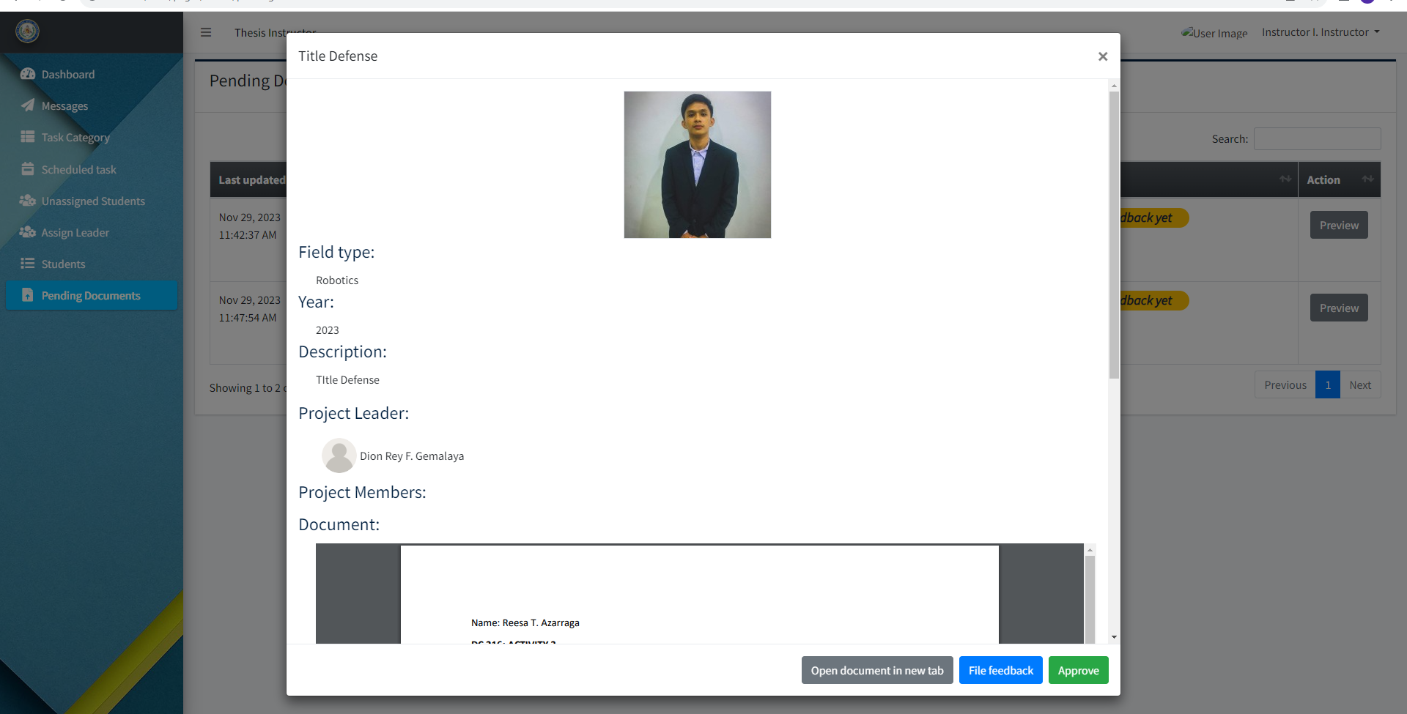

After the student uploaded their thesis document, the thesis coordinator and thesis adviser can approve it at the “Pending Documents” tab before the document goes to the thesis panels.

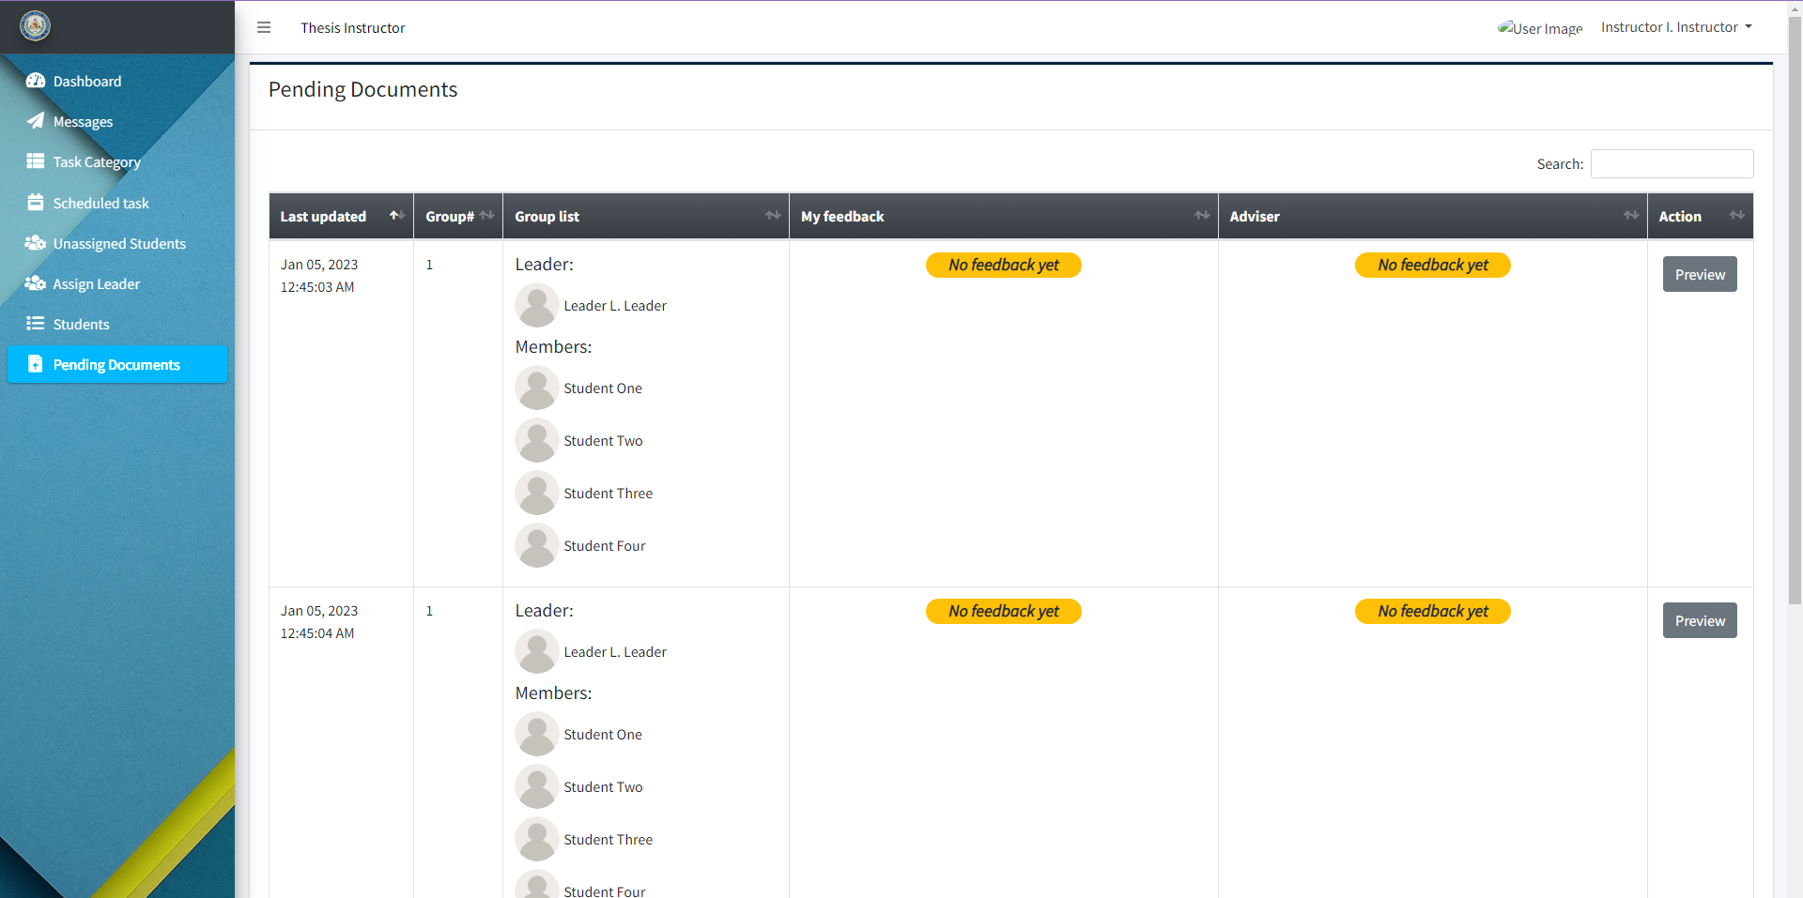

“Pending Documents” tab in the Thesis Instructor dashboard that allows access to what documents were uploaded by the student in the system.

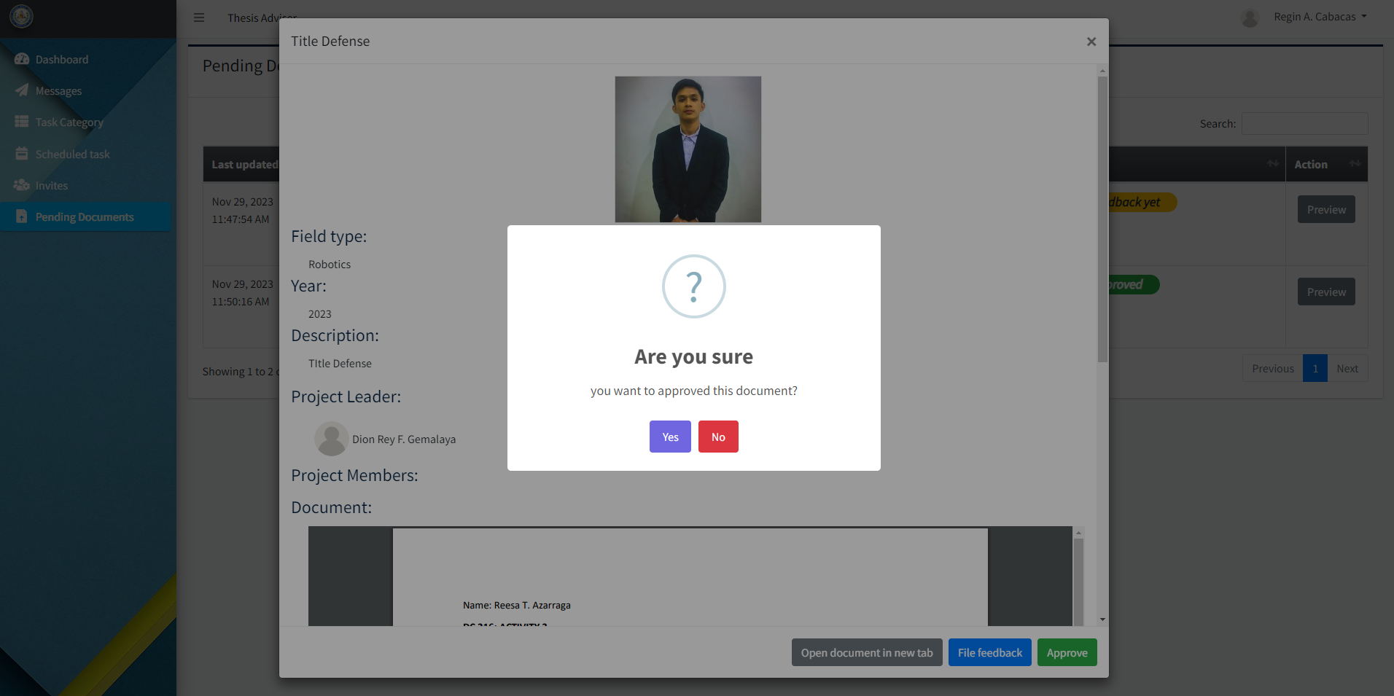

Preview before the approval of the thesis document.

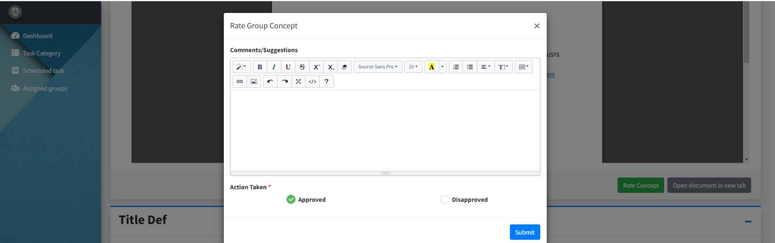

After the uploaded thesis document gets approved, it will be shown to the panel's dashboard where they can add comments/ suggestions and approve or disapprove the thesis concept.

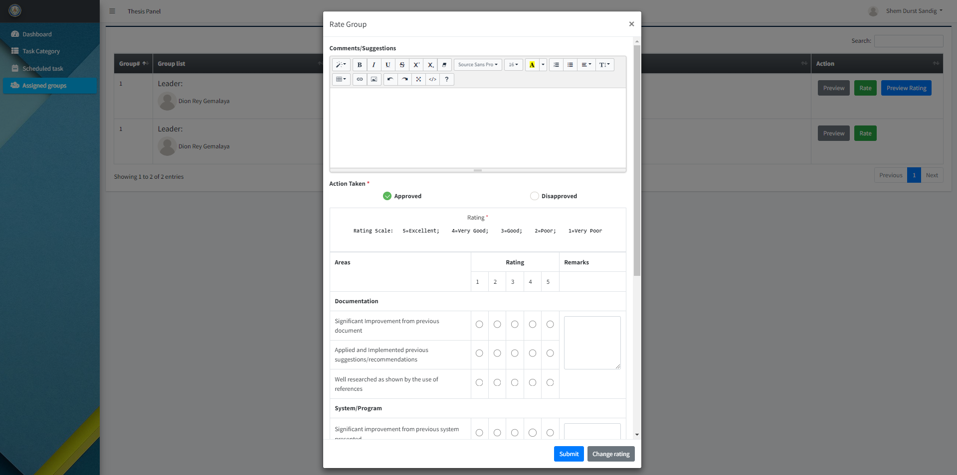

Panel dashboard for 20%, 50%, and final defense which allows them to give rating and remarks to the thesis.

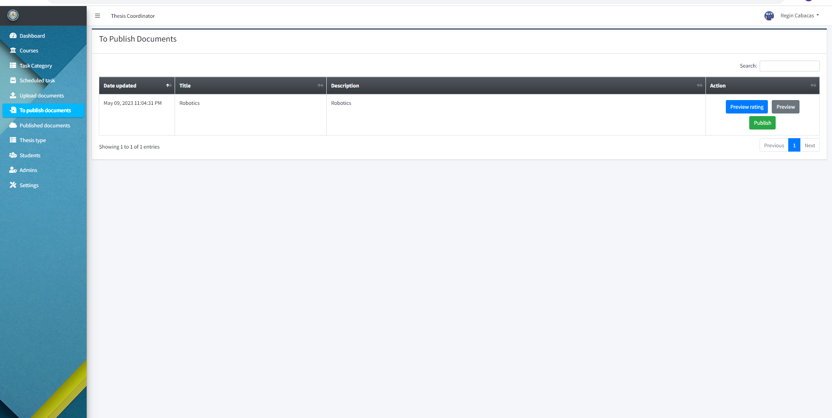

Once the thesis gets approved it can be now published to the system.

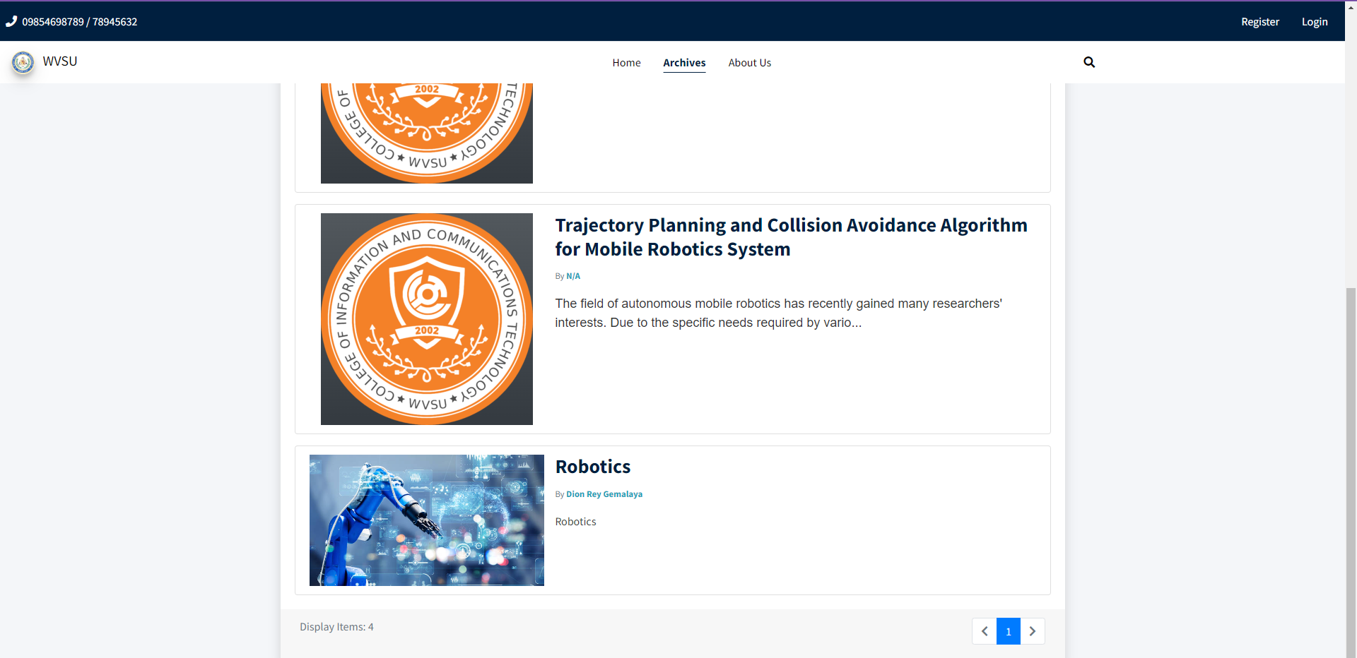

Published documents can be seen on the “Archives” tab.

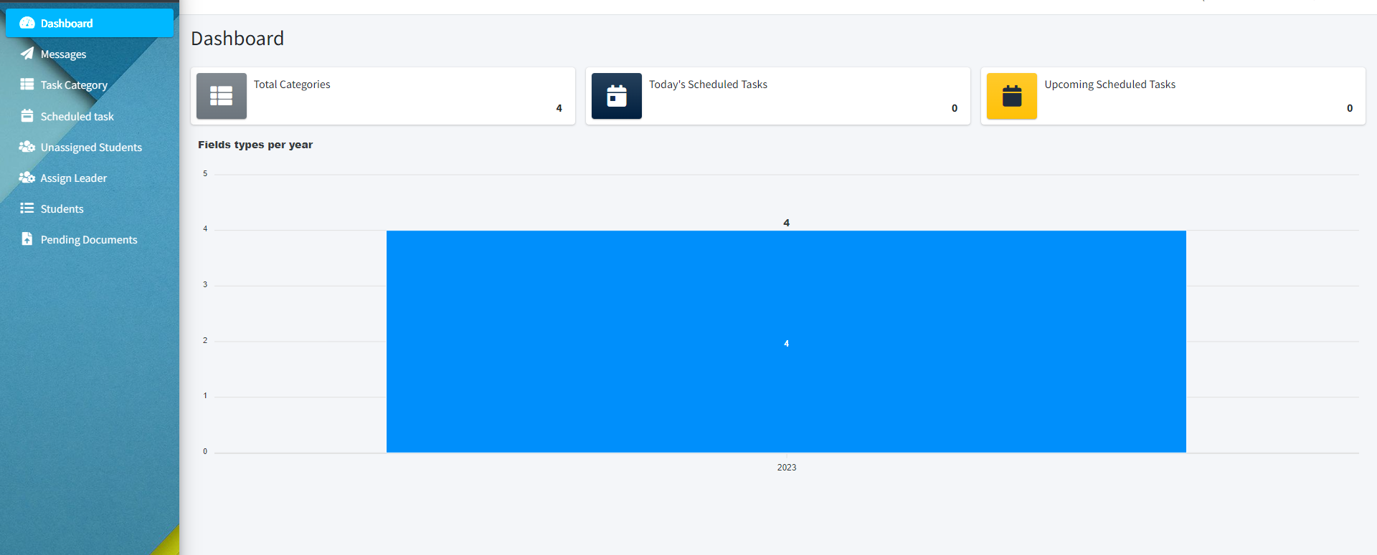The Thesis Coordinator dashboard displays the quantity and the category of archived theses uploaded to the system.

# Troubleshooting

# 

# FAQ

1. **Do I need to install the system to be able to use it?**

No, you can access the system on your browser. No need to worry about compatibility issues or downloading any additional software. Students and faculty members can conveniently access the web-based system from any device with internet connection.

1. **Can I delete my account?**

You can't delete your account but the system administrator can. Once you create an account on the web-based system, it is permanent and cannot be deleted. This ensures that accounts and the valuable contributions associated with them remain in the system for future reference.

1. **Can non-CICT students use the system?**

No, only students from CICT can use it. The web-based system is designed exclusively for the students and faculty members of the CICT department, ensuring that all the features and resources cater to the specific needs of this academic community.

1. **How can I reset my account password?**

Click reset password. If you forget your password, you can easily reset it by clicking on the "reset password" option provided on the web-based system.

1. **I didn't get my password reset email.**

Make sure to check your spam or junk folder if you do not receive the email within a few minutes, sometimes emails from unknown can end up in these folders. Also,, double-check that you have entered the correct email address associated with your account during the password reset process. If you still cannot find the email, you may need to contact the system administrator for assistance.

1. **Can I change the email address I used to register?**

You cannot change the email you used to register in the system. This measure aims to maintain the integrity of the system and prevent any unauthorized access to the stored theses. Additionally, the system will have secure login credentials and authentication procedures to protect sensitive information.

1. **Which browsers does the system work on?**

The system works on any browsers (Google Chrome, Safari, Internet Explorer. etc.) except for Firefox. The technical team has identified a compatibility issue between Firefox and the system, which has caused certain functionalities to not work as intended.

1. **Can I download documents?**

You cannot download the documents from the system, ensuring the security and confidentiality of the stored theses to safeguard the intellectual property of the students and maintain academic integrity. Additionally, the inability to download documents from the system eliminates the risk of unauthorized distribution or misuse of the theses, guaranteeing that the hard work and efforts put in by the students remain solely for academic purposes within the institution.. However, users will still have the ability to view and read the documents.

**ADMIN CREDENTIALS**   
**Coordinator:** [coordinator@gmail.com](mailto:coordinator@gmail.com) : password

**Instructor:** [instructor@gmail.com](mailto:instructor@gmail.com) : password

**Adviser :** [adviser@gmail.com](mailto:adviser@gmail.com) : password

**Panel :** [panel_one@gmail.com](mailto:panel_one@gmail.com) : password

# Contact Details

[DION REY GEMALAYA](mailto:dionrey.gemalaya@wvsu.edu.ph)**–** dionrey.gemalaya@wvsu.edu.ph

[EVELYN SOTELA](mailto:evelyn.sotela@wvsu.edu.ph)**–** evelyn.sotela@wvsu.edu.ph

[ANGIE ROSE AZUCENA](mailto:angierose.azucena@wvsu.edu.ph)**–** angierose.azucena@wvsu.edu.ph

[EDEN FAITH TAGUDANDO](mailto:edenfaith.tagudando@wvsu.edu.ph)**–** edenfaith.tagudando@wvsu.edu.ph

# 

Pretend this is a back cover.